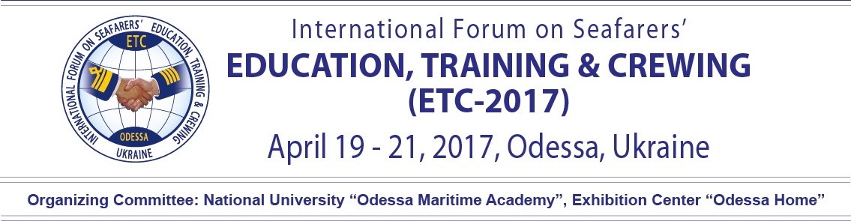

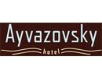
Aquavita
Lufthansa City Center Tel: +38 048 734 87 03
Pushkinskaya st., 11, ap. 27 Tel: +38 048 738 44 88
Odessa 65026 Fax: +38 048 738 47 29
Ukraine Mob: +38 067 558 17 08
Email:irinapir@ods.aqua.com.ua

Hotel | AYVAZOVSKY 4*
Guest name, Contaots: | Guest___________________________________________________  Tel.___________________e-mail_____________________________
Arival/Departure: | _______________2017 (14:00)______________2017(12:00)
Room type | Special rates  Standard 1080 UAH 950 UAH  Standard Superior 1180 UAH 1050 UAH  Standard Mansard 1180 UAH 1050 UAH  Junior Suite 1850 UAH 1600 UAH  Suite 2100 UAH 1800 UAH
Breakfast (buffet), per day | free
Payment method: | __ Credit card*  __ Cash  __Wire transfer (official data is required)
* Kindly ask to provide the following information, in case of credit card payment:
card № ______ ______ ______ ______, CVV2 (for Visa) / CVC 2 (for Eurocard/MasterCard, American Express) (3 last items of the backside of your card) ________________, valid till ________________, bank __________________________________________.
Cardholder signature ______________________________

Additionally has to be paid: tourist tax 1% from the accommodation cost.
Please, note: arrival time is – 14:00 departure time – 12:00.
Early check in and late check out is extra payment. Kindly ask to tell us beforehand.
Cancellation is accepted less than 3 days prior arrival. In case of late cancellation or no show one night stay will be charged.
Kindly ask to fill in the form and send us back via e-mail: irinapir@ods.aqua.com.ua

