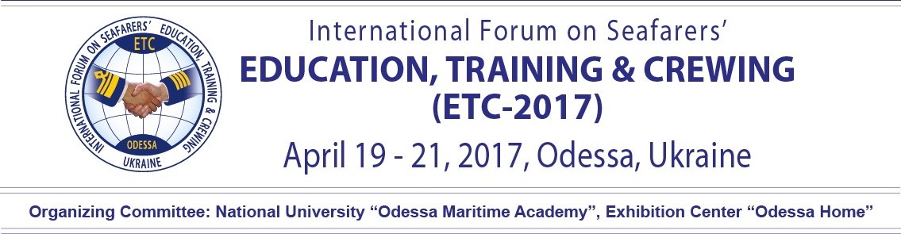

Aquavita
Lufthansa City Center Tel: +38 048 734 87 03
Pushkinskaya st., 11, ap. 27 Tel: +38 048 738 44 88
Odessa 65026 Fax: +38 048 738 47 29
Ukraine Mob: +38 067 558 17 08

Email:irinapir@ods.aqua.com.ua

Hotel | BRISTOL 5*
Guest name, Contaots: | Guest___________________________________________________  Tel.___________________e-mail_____________________________
Arival/Departure: | _______________2017 (14:00)______________2017(12:00)
Room type | Special rates  Standard 2350 UAH 2100 UAH  Superior 2750 UAH 2500 UAH  Junior Suite 5750 UAH 5500 UAH
Breakfast (buffet), per day | - free
Payment method: | __ Credit card*  __ Cash  __Wire transfer (official data is required)
* Kindly ask to provide the following information, in case of credit card payment:
card № ______ ______ ______ ______, CVV2 (for Visa) / CVC 2 (for Eurocard/MasterCard, American Express) (3 last items of the backside of your card) ________________, valid till ________________, bank __________________________________________.
Cardholder signature ______________________________

Additionally has to be paid: tourist tax 1% from the accommodation cost.
Please, note: arrival time is – 14:00 departure time – 12:00.
Early check in and late check out is extra payment. Kindly ask to tell us beforehand.
Cancellation is accepted less than 3 days prior arrival. In case of late cancellation or no show one night stay will be charged.
Kindly ask to fill in the form and send us back via e-mail: irinapir@ods.aqua.com.ua

